|  |
| --- |
| **Lockedme.com**  *(Application Screenshot’s)* |

* **Version History:**

|  |  |  |
| --- | --- | --- |
| 1. | **Author Name** | Tushar Khillare. |
| 2. | **Purpose** | Screenshots of Application. |
| 3. | **Date** | 8 August 2021 |
| 4. | **Version** | 1.0 |

Contents

**1.Main Menu Screenshot’s.** 3

**2. Project Outputs.** 4

# 

# **1.Main Menu Screenshot’s.**

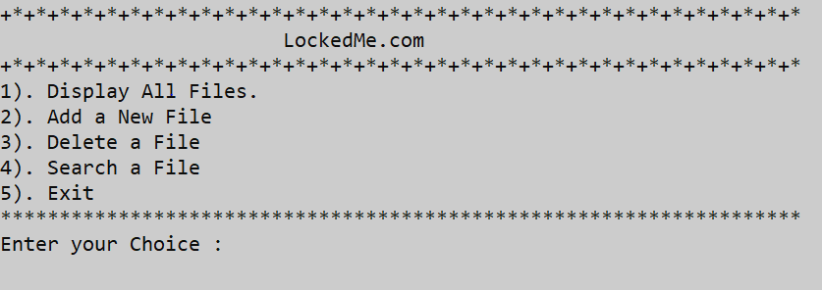

# **2. Project Outputs.**

|  |
| --- |
| 1. Display All Files. |
|  |
| 1. Add a new file. |
| ` |
| 1. Delete a File. |
|  |
| 1. Search a File. |
| 1. Exit through Menu. |